* Crowfoot – Introduced by Gordon Everest, the distinctive arrows are called so as they resemble a crow’s foot but are also called inverted arrows, chicken feet or just forks. This is a method often used to create an entity-relationship diagram which has entities as boxes and relationships as lines between boxes, with the relative cardinality being represented by different shapes at the ends of these lines.

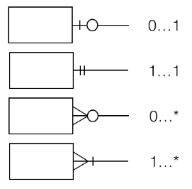

* Chen – Developed by Peter Chen, this notation uses rectangles to represent entities and the relationships between them is represented by a diamond shape with descriptive text. These diagrams are well suited for brainstorming and quick diagrams as a first step to understand basic database structures.

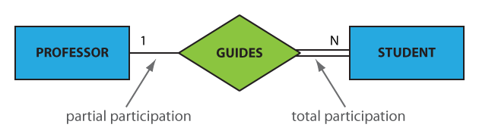

* UML - The UML (Unified Modeling Language) is a general-purpose software notation. It consists of shapes, symbols, and notations to graphically depict each component that makes up a database, its attributes, and how it relates to other each other. It is useful to build model large and complex systems. In UML, entity is represented by a rectangle and relationships are represented by lines with cardinality specified at the ends of the lines.

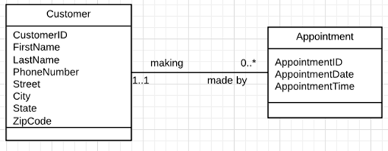

I prefer the UML notation as it is more detailed in nature and is a frequently used industry standard that I had a chance to work with and communicated the flow easily to my stakeholders.